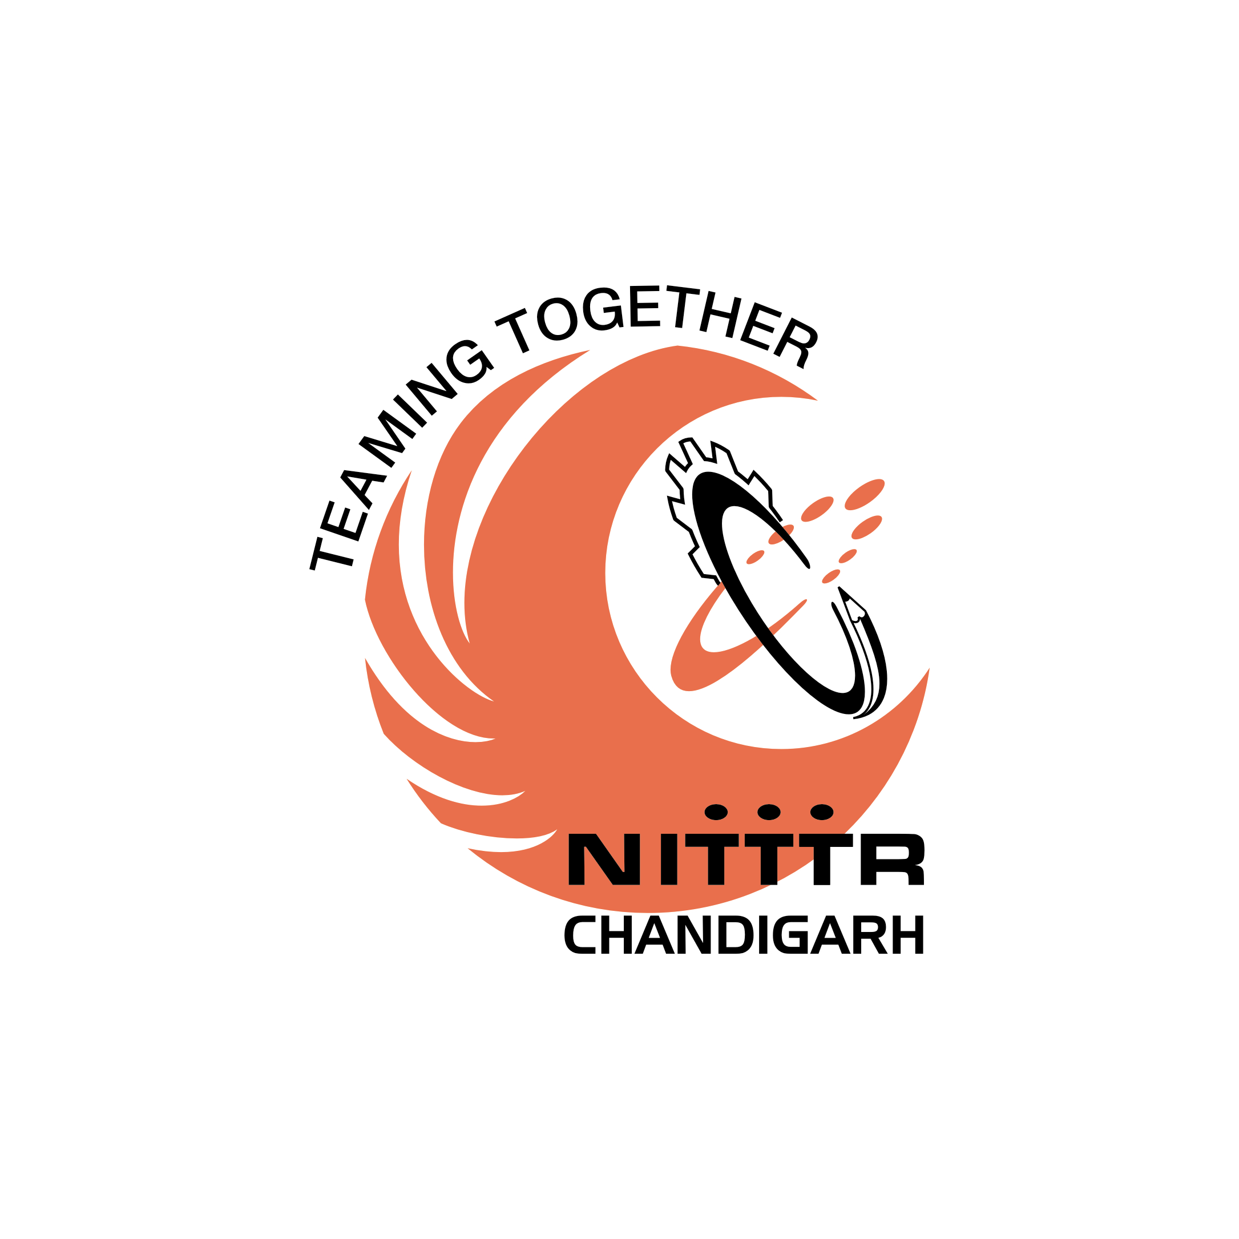NATIONAL INSTITUTE OF TECHNICAL TEACHERS TRAINING AND RESEARCH
SECTOR 26, CHANDIGARH – 160 019
(An Autonomous Institution under the MHRD, Government of India)
Website: www.nitttrchd.ac.in

Advertisement No. 133/2017

Applications on prescribed form are invited for the following posts of Professors (Group-A) in the Pay Band of
Rs. 37400-67000 (AGP Rs 10000/-) (To be revised as per 7th CPC)

Sr. No. | Name of the Department | No. of Posts
1 | Civil Engineering | One
2 | Computer Science and Engineering | One
3 | Electronics and Communication Engineering | One
4 | Electrical Engineering | One
5 | Mechanical Engineering | One
6 | Applied Science | One

Application form and general information can be downloaded from the institute Website: www.nitttrchd.ac.in

Qualifications and other criteria are as approved by AICTE and can be downloaded from the institute website (www.nitttrchd.ac.in)

Application Fee & last date of receiving

Rs 100/- (for General/OBC Category) .No fee is required for SC/ST/Differently abled persons (PWD)/ women candidates/ internal candidates of this institute.

Applications complete in all respects along with requisite fee (non refundable) through Indian Postal Order/Demand Draft payable to Director, National Institute of Technical Teachers Training and Research, Sector 26, Chandigarh should reach the Faculty Incharge Administration by 15th January, 2018

The number of posts is tentative and institute reserves the right to fill-up or not to fill-up any post(s) without assigning any reason. The application received in unprescribed format or received after the last date or without fee will not be considered and no correspondence in this regard will be entertained.

DIRECTOR

